# WEEK 3 Notes

**Lesson 1: Episodic Sarsa with Function Approximation**

* Explain the update for Episodic Sarsa with function approximation
* 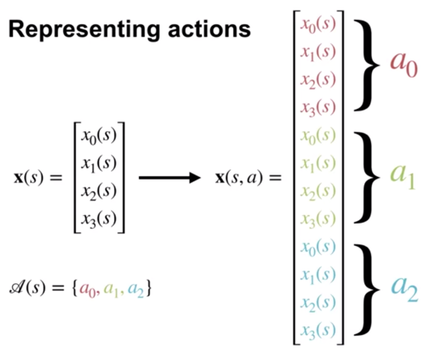
* Introduce the feature choices, including passing actions to features or stacking state features

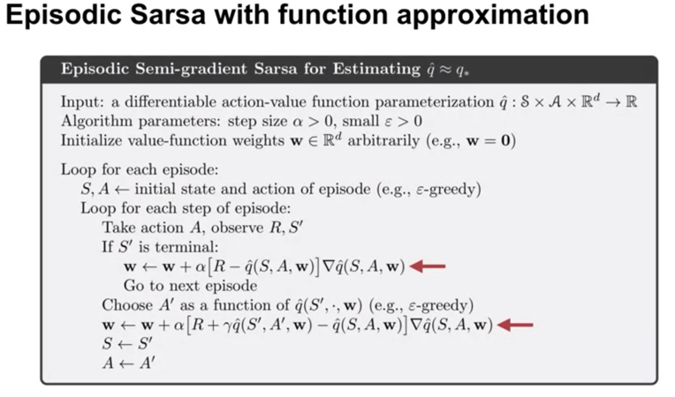

* Visualize value function and learning curves
* Discuss how this extends to Q-learning easily, since it is a subset of Expected Sarsa
  + 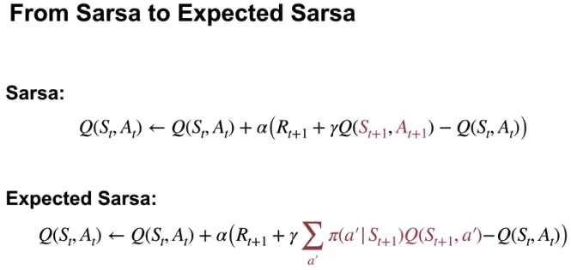
  + 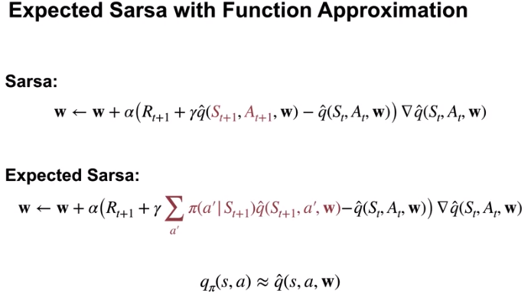
  + 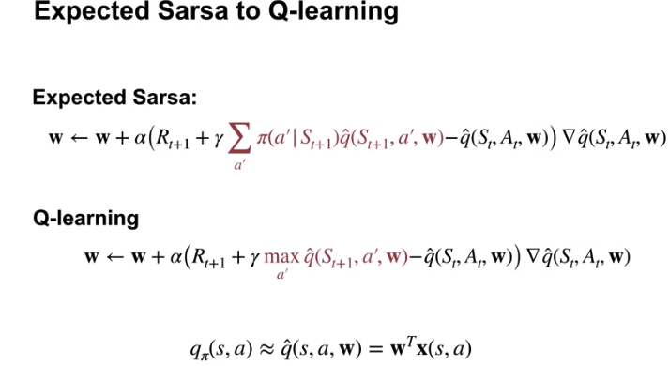

**Lesson 2: Exploration under Function Approximation**

* Understanding optimistically initializing your value function as a form of exploration

**Lesson 3: Average Reward**

* Describe the average reward setting
* Explain when average reward optimal policies are different from discounted solutions
* 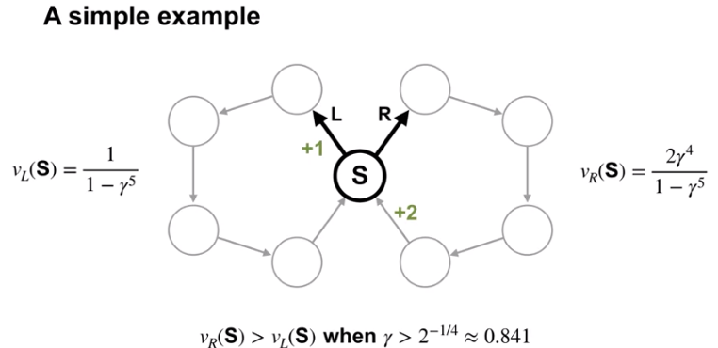
* Understand how differential value functions are different from discounted value functions
* ns
 